CO2 ASSESSMENT2
1.Given the scenario of a School Management System, identify relations and write SQL to list all students with their class teacher and grade.
- STUDENT
Attribute | Data Type
StudentID (PK) | INT
StudentName | VARCHAR(50)
ClassID (FK) | INT
Grade | CHAR(2)
- CLASS
Attribute | Data Type
ClassID (PK) | INT
ClassName | VARCHAR(20)
TeacherID (FK) | INT
- TEACHER
Attribute | Data Type
TeacherID (PK) | INT
TeacherName | VARCHAR(50)
Subject | VARCHAR(30)

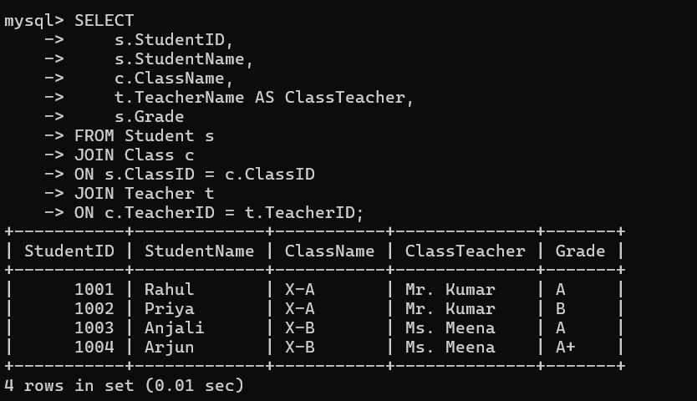
Explanation
- Student table stores student details and grades.
- Class table stores class information and the assigned class teacher.
- Teacher table stores teacher details.
- The query uses INNER JOIN to combine the three tables and display:
  - Student ID
  - Student Name
  - Class Name
  - Class Teacher
  - Grade

Question 2: A hospital wants to track patient appointments. Design the relational schema and write SQL to find doctors with more than 10 appointments this month.
Relations
1. DOCTOR
Attribute | Data Type
DoctorID (PK) | INT
DoctorName | VARCHAR(50)
Specialization | VARCHAR(50)
2. PATIENT
Attribute | Data Type
PatientID (PK) | INT
PatientName | VARCHAR(50)
Age | INT
Gender | VARCHAR(10)
3. APPOINTMENT
Attribute | Data Type
AppointmentID (PK) | INT
PatientID (FK) | INT
DoctorID (FK) | INT
AppointmentDate | DATE
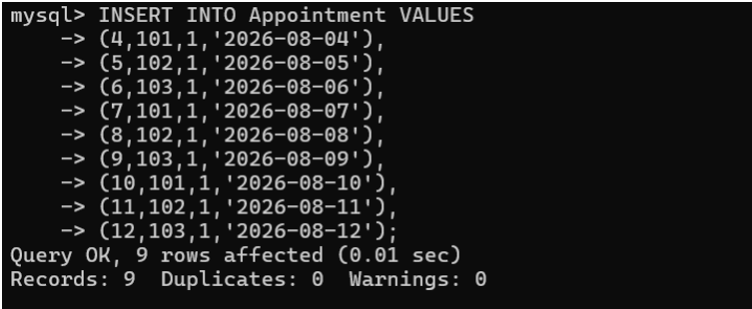

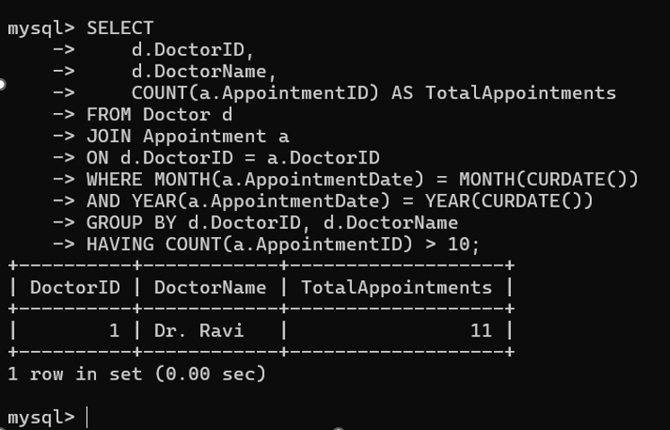

Question 3: In an e-commerce scenario, write SQL queries using sub-queries to find products that have never been ordered.
Relations
1. PRODUCT
Attribute | Data Type
ProductID (PK) | INT
ProductName | VARCHAR(50)
Price | DECIMAL(10,2)
2. ORDERS
Attribute | Data Type
OrderID (PK) | INT
CustomerName | VARCHAR(50)
OrderDate | DATE

3.ORDERITEM
Attribute | Data Type
OrderID (FK) | INT
ProductID (FK) | INT
Quantity | INT
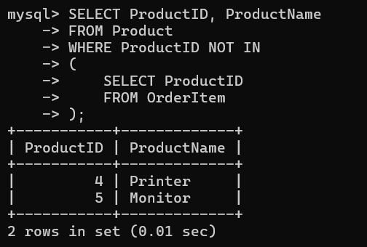

Question 4: For a university database, write relational algebra expressions to find students enrolled in both 'DBMS' and 'OS' courses.
Relations
STUDENT
Student(StudentID, StudentName)
COURSE
Course(CourseID, CourseName)
ENROLLMENT
Enrollment(StudentID, CourseID)
Relational Algebra Expression
Step 1: Find students enrolled in DBMS
R1 ← πStudentID (σCourseName='DBMS' (Course ⨝ Enrollment))
Step 2: Find students enrolled in OS
R2 ← πStudentID (σCourseName='OS' (Course ⨝ Enrollment))
Step 3: Find students enrolled in both DBMS and OS
R1 ∩ R2
Step 4: Display student details
πStudentID, StudentName (Student ⨝ (R1 ∩ R2))
Final Relational Algebra Expression
πStudentID, StudentName
(
Student ⨝
(
πStudentID(σCourseName='DBMS'(Course ⨝ Enrollment))
∩
πStudentID(σCourseName='OS'(Course ⨝ Enrollment))
)
)

Explanation
- Select students enrolled in the DBMS course.
- Select students enrolled in the OS course.
- Use the intersection (∩) operator to find students common to both courses.
- Join with the Student relation to display the Student ID and Student Name.

Question 5: Given a payroll scenario, create a view showing employees whose salary is below department average and write a query to update their salary by 10%.

Relations (Tables)

EMPLOYEE
Attribute | Data Type
EmpID (PK) | INT
EmpName | VARCHAR(50)
DeptID | INT
Salary | DECIMAL(10,2)

DEPARTMENT
Attribute | Data Type
DeptID (PK) | INT
DeptName | VARCHAR(50)
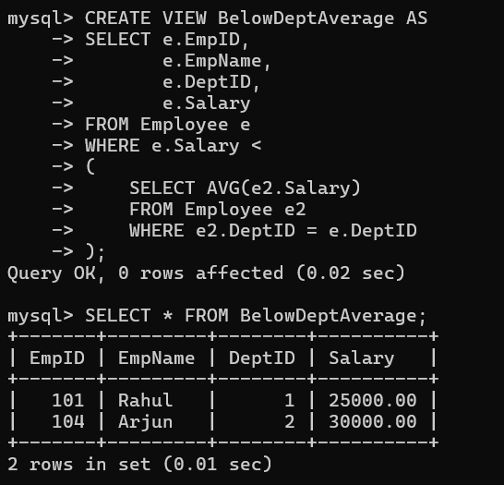

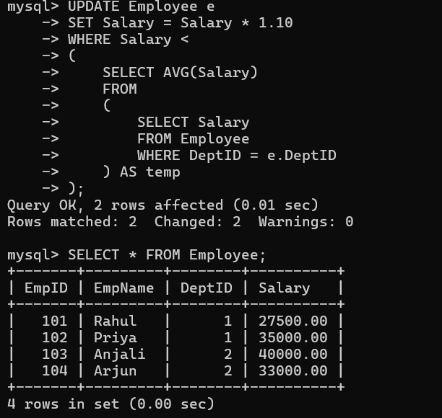
Question 6: In a banking scenario, apply JOIN operations to retrieve customer account details, transaction history, and branch information.
Relations (Tables)
CUSTOMER
Attribute | Data Type
CustomerID (PK) | INT
CustomerName | VARCHAR(50)
AccountID (FK) | INT
ACCOUNT
Attribute | Data Type
AccountID (PK) | INT
AccountType | VARCHAR(20)
Balance | DECIMAL(10,2)
BranchID (FK) | INT
TRANSACTION
Attribute | Data Type
TransactionID (PK) | INT
AccountID (FK) | INT
TransactionDate | DATE
Amount | DECIMAL(10,2)
BRANCH
Attribute | Data Type
BranchID (PK) | INT
BranchName | VARCHAR(50)
City | VARCHAR(50)

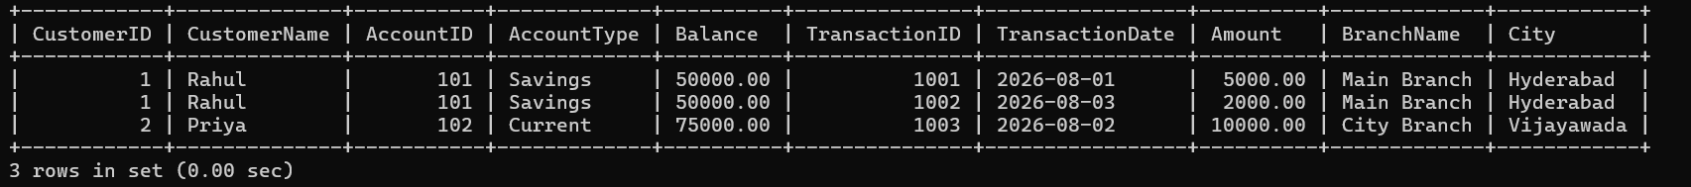
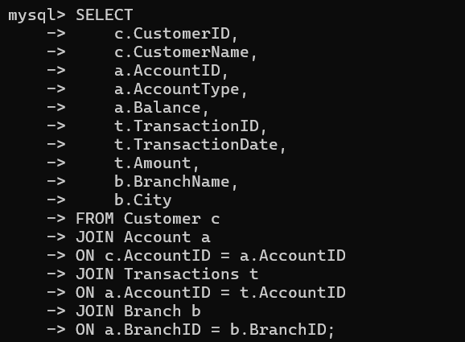

This solution demonstrates the use of INNER JOIN to retrieve:
- Customer details
- Account details
- Transaction history
- Branch information

Question 7: A retail store needs daily sales summary. Write SQL with GROUP BY and HAVING to report total sales per category exceeding Rs. 10,000.

Relations (Tables)

CATEGORY
Attribute | Data Type
CategoryID (PK) | INT
CategoryName | VARCHAR(50)

PRODUCT
Attribute | Data Type
ProductID (PK) | INT
ProductName | VARCHAR(50)
CategoryID (FK) | INT

SALES
Attribute | Data Type
SaleID (PK) | INT
ProductID (FK) | INT
SaleDate | DATE
Amount | DECIMAL(10,2)
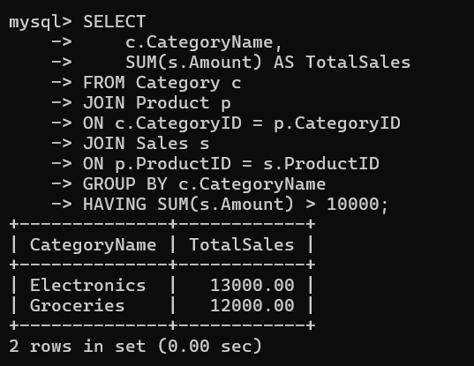

Question 8: For a library system scenario, construct Tuple Relational Calculus (TRC) expressions to find members who borrowed books from all genres.

Relations
MEMBER
Member(MemberID, MemberName)
BOOK
Book(BookID, Title, Genre)
BORROW
Borrow(MemberID, BookID)
Tuple Relational Calculus (TRC) Expression
{ m.MemberName |
Member(m) ∧
∀g (
(∃b (Book(b) ∧ b.Genre = g.Genre))
→
∃br ∃bk (
Borrow(br) ∧
Book(bk) ∧
br.MemberID = m.MemberID ∧
br.BookID = bk.BookID ∧
bk.Genre = g.Genre
)
)
}
Simplified TRC (Suitable for DBMS Assignment)
{ M.MemberName |
Member(M) ∧
∀G (
Book(G)
→
∃B (
Borrow(B) ∧
B.MemberID = M.MemberID ∧
B.BookID = G.BookID
)
)
}
Explanation
- Member(M) selects each library member.
- Book(G) represents every book (and hence every genre).
- Borrow(B) checks the borrowing records.
- The universal quantifier (∀) ensures that the member has borrowed at least one book from every genre.
- The expression returns the names of members who have borrowed books from all available genres.

Question 9: Given an inventory management scenario, define CHECK and FOREIGN KEY constraints and demonstrate their enforcement through SQL.

Relations

CATEGORY
Attribute | Data Type
CategoryID (PK) | INT
CategoryName | VARCHAR(50)

PRODUCT
Attribute | Data Type
ProductID (PK) | INT
ProductName | VARCHAR(50)
Price | DECIMAL(10,2)
Quantity | INT
CategoryID (FK) | INT

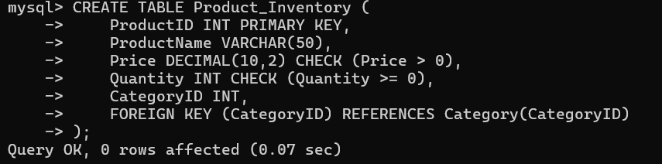
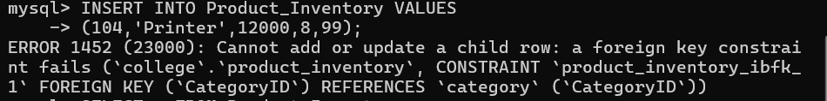
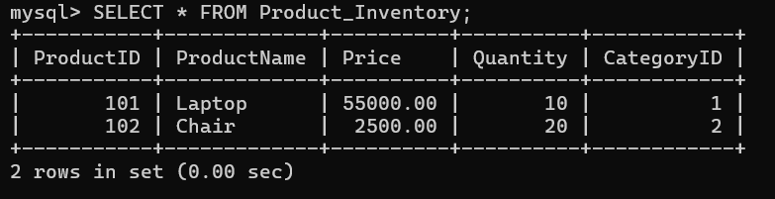

Question 10: Design a relational schema for an HR system and create materialized views for monthly attendance and performance summaries.
Relations
EMPLOYEE
Attribute | Data Type
EmpID (PK) | INT
EmpName | VARCHAR(50)
Department | VARCHAR(50)
ATTENDANCE
Attribute | Data Type
AttendanceID (PK) | INT
EmpID (FK) | INT
Month | VARCHAR(20)
DaysPresent | INT
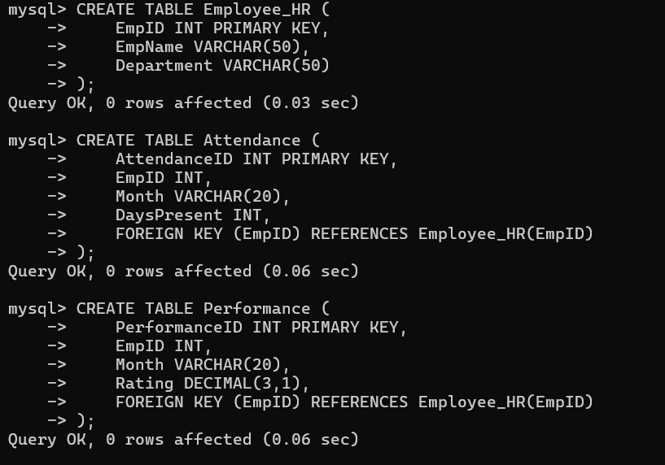
PERFORMANCE
Attribute | Data Type
PerformanceID (PK) | INT
EmpID (FK) | INT
Month | VARCHAR(20)
Rating | DECIMAL(3,1)

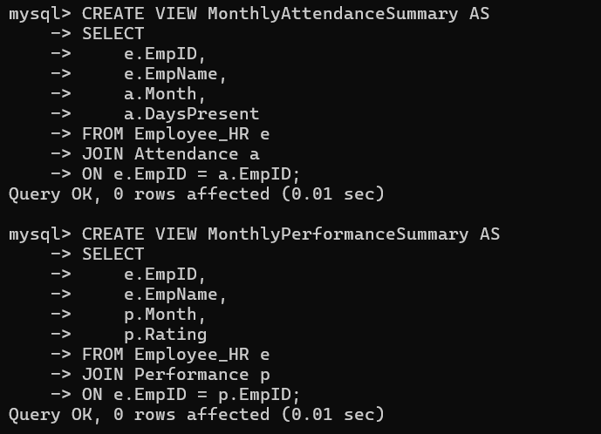

Output:
